Assignment-2

Password changing

* Login into your account and then change password?
  + Change your password into ***IneuR0n#42*** and hit the **Enter** key
    - Explain what happen and give screenshot?

This is the strongest and suggested password for the new user who creates on centos.

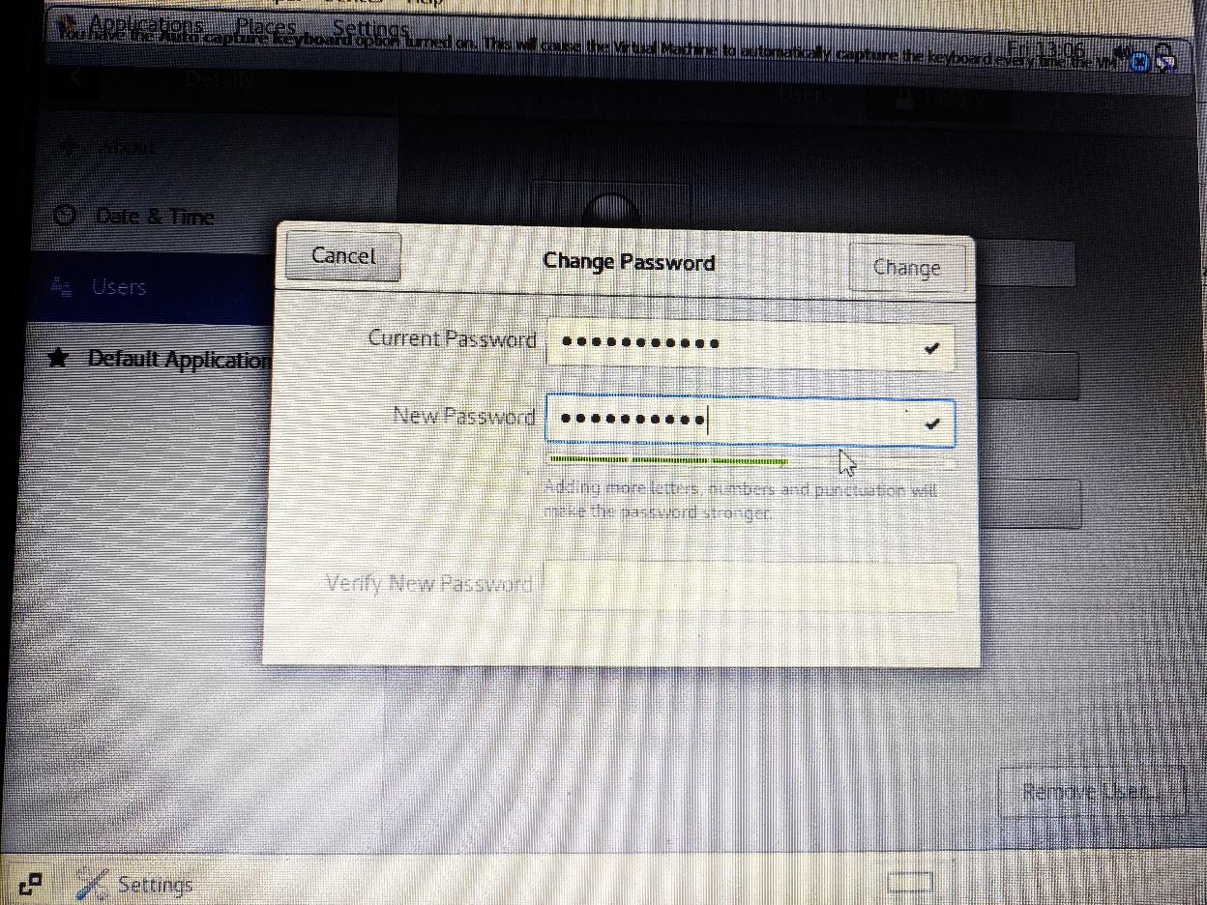

* + Try again to change password but use like password ***1234*** or ***abcd***
    - Explain what happen and give screenshot?

The password needs to be longer and stronger for the user

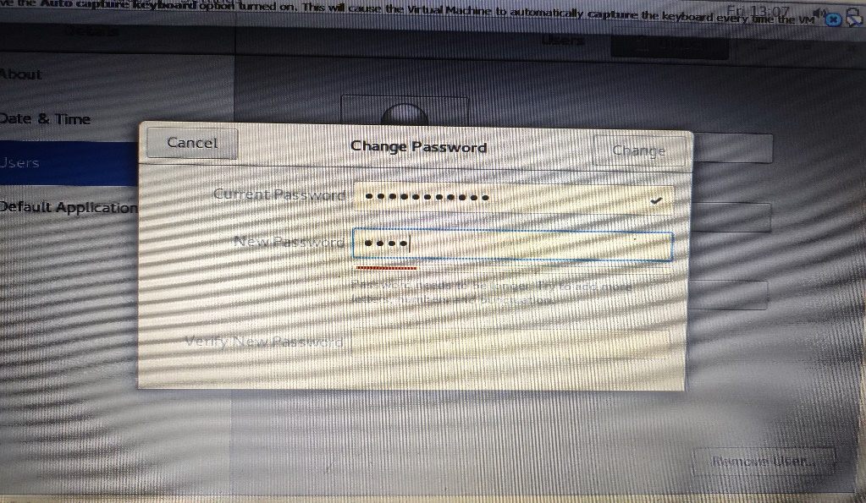

Try again to change password but now don’t use any password just hit **Enter** key

* + - Explain what happen and give screenshot?

The password will not get changed.

